International University
School of Computer Science and Engineering



Computer Graphics
Lab 02 – Transformation

Semester: 1, Year: 2026 - 2027
Lab Instructor: MSc. Tran Khai Minh

Full name: Võ Trí Khôi
Student ID: ITCSIU24045
Group: G01

1. INTRODUCTION
This report documents the completion of Lab 2 for the Computer Graphics course. For each exercise, we present the solution code, describe the key implementation details, and explain the underlying computer graphics concepts, including the mathematics of transformation matrices and the OpenGL rendering pipeline.

2. EXERCISE 1 – UNIFORM DATA
2.1. Part A – Vertex Transformation
2.1.1. General form of this transformation in matrix form (homogeneous coordinates)
For a 2D translation by a t_{x} along the X-axis and t_{y} distance along the Y-axis, the transformation matrix in 3x3 homogeneous coordinates is:
T = $\left[\begin{matrix}1 & 0 & tx \\ 0 & 1 & ty \\ 0 & 0 & 1\end{matrix}\right]$
When multiplied by a 2D point represented as a 3D homogeneous column vector ${\left(x , y , 1\right)}^{T}$, it correctly adds the translation:
$\left[\begin{matrix}1 & 0 & tx \\ 0 & 1 & ty \\ 0 & 0 & 1\end{matrix}\right]\left[\begin{matrix}x \\ y \\ 1\end{matrix}\right]$=$\left[\begin{matrix}x+tx \\ y+ty \\ 1\end{matrix}\right]$

2.1.2. Explain why we need the extra '1' in the homogeneous coordinate system
In standard 2D Cartesian coordinates $\left(x , y\right)$, a 2x2 matrix can only perform linear transformations (like scaling and rotation) through multiplication, because multiplying a matrix by the origin $\left(0 , 0\right)$will always result in $\left(0 , 0\right)$.
Translation is an affine transformation (it involves adding a constant offset). Without the extra '1', we cannot express translation as a simple matrix multiplication. By adding a 3rd dimension $w$(where $w=1$), we embed our 2D space into a 3D space. This allows the matrix multiplication to capture the addition components ($1×t_{x}$ and $1×t_{y}$), allowing us to combine translations, rotations, and scales into a single unified matrix multiplication pipeline.

2.2. Part B – Translation in Animation-1
2.2.1. Translation matrix for a 2D translation by (t_{x}, t_{y})
The translation matrix for this animation is: $T=\left[\begin{matrix}1 & 0 & t_{x} \\ 0 & 1 & t_{y} \\ 0 & 0 & 1\end{matrix}\right]$
In animation-1.py, the triangle starts with a translation offset of $t_{x}=-0.5$. Every frame, it increases by $Δx=0.03$. $t_{y}$remains $0.0$. Applying this to the vertex $V={\left(0.0 , 0.2 , 1\right)}^{T}$:
- Frame 0 (Initial State): $t_{x}=-0.5\left[\begin{matrix}1 & 0 & -0.5 \\ 0 & 1 & 0 \\ 0 & 0 & 1\end{matrix}\right]\left[\begin{matrix}0.0 \\ 0.2 \\ 1\end{matrix}\right]=\left[\begin{matrix}0.0-0.5 \\ 0.2+0 \\ 1\end{matrix}\right]=\left[\begin{matrix}-0.5 \\ 0.2 \\ 1\end{matrix}\right]$
- Frame 1: $t_{x}=-0.5+0.03=-0.47\left[\begin{matrix}1 & 0 & -0.47 \\ 0 & 1 & 0 \\ 0 & 0 & 1\end{matrix}\right]\left[\begin{matrix}0.0 \\ 0.2 \\ 1\end{matrix}\right]=\left[\begin{matrix}-0.47 \\ 0.2 \\ 1\end{matrix}\right]$
- Frame 2: $t_{x}=-0.47+0.03=-0.44\left[\begin{matrix}1 & 0 & -0.44 \\ 0 & 1 & 0 \\ 0 & 0 & 1\end{matrix}\right]\left[\begin{matrix}0.0 \\ 0.2 \\ 1\end{matrix}\right]=\left[\begin{matrix}-0.44 \\ 0.2 \\ 1\end{matrix}\right]$

2.2.2. Why does the program reset the x-translation when x > 1.2?
OpenGL's Normalized Device Coordinates (clip space) always range from -1.0 to 1.0 on both the X and Y axes. Any geometry outside this range is clipped (cut off) and won't appear on the screen.
In the code, the triangle's local X coordinates span from -0.2 to 0.2.
- When the translation reaches $x=1.2$, the left-most vertex of the triangle (which is at $-0.2$) will be at world position $1.2-0.2=1.0$.
- At $x≥1.2$, the entire triangle is at or beyond $1.0$, meaning it has completely exited the right side of the visible screen.
- The program resets the translation to $-1.2$. Because the right-most vertex is at $+0.2$, its new world position becomes $-1.2+0.2=-1.0$. This places the triangle perfectly just outside the left edge of the screen, creating a seamless wrapping animation.

2.3. Part C – Circular Motion in Animation-2
2.3.1. Derive these equations from the unit circle definition
By definition, a point on a unit circle (radius $r=1$) centered at the origin forms a right-angled triangle with the X-axis.
The hypotenuse is the radius ($1$). Basic trigonometry states that $cos⁡\left(θ\right)=\frac{\text{adjacent}}{\text{hypotenuse}}=\frac{x}{1}$, and $sin⁡\left(θ\right)=\frac{\text{opposite}}{\text{hypotenuse}}=\frac{y}{1}$.
Therefore, $x=cos⁡\left(θ\right)$and $y=sin⁡\left(θ\right)$.
For a circle scaled to an arbitrary radius $r$, the hypotenuse becomes $r$, meaning $cos⁡\left(θ\right)=\frac{x}{r}$and $sin⁡\left(θ\right)=\frac{y}{r}$.
Rearranging these gives the parametric equations for a circle: $x=r⋅cos⁡\left(θ\right)$and $y=r⋅sin⁡\left(θ\right)$.
If a point is moved by this circular path, the translation offsets are $t_{x}=rcos⁡\left(θ\right)$and $t_{y}=rsin⁡\left(θ\right)$. The translation matrix is: $T=\left[\begin{matrix}1 & 0 & rcos⁡\left(θ\right) \\ 0 & 1 & rsin⁡\left(θ\right) \\ 0 & 0 & 1\end{matrix}\right]$

2.3.2. Show how the vertex (0.0, 0.2) is transformed at: $t=0,t=π/2,t=π$
In animation-2.py, the radius $r=0.75$, time is $θ$, and the vertex to transform is $V=\left(0.0 , 0.2\right)$. The formula for the new position is $V^{'}=\left(0.0 , +0.75cos⁡\left(t\right)0.2+0.75sin⁡\left(t\right)\right)$.
- At $t=0$:
$$cos⁡\left(0\right)=1,sin⁡\left(0\right)=0$$
$$t_{x}=0.75\left(1\right)=0.75$$
$$t_{y}=0.75\left(0\right)=0.0$$
Result: $\left(0.0 , +0.750.2+0.0\right)=\left(0.75 , 0.2\right)$(The triangle is shifted to the far right)
- At $t=π/2$:
$$cos⁡\left(π/2\right)=0,sin⁡\left(π/2\right)=1$$
$$t_{x}=0.75\left(0\right)=0.0$$
$$t_{y}=0.75\left(1\right)=0.75$$
Result: $\left(0.0 , +0.00.2+0.75\right)=\left(0.0 , 0.95\right)$(The triangle is shifted to the top)
- At $t=π$:
$$cos⁡\left(π\right)=-1,sin⁡\left(π\right)=0$$
$$t_{x}=0.75\left(-1\right)=-0.75$$
$$t_{y}=0.75\left(0\right)=0.0$$
Result: $\left(0.0 , -0.750.2+0.0\right)=\left(- , 0.750.2\right)$(The triangle is shifted to the far left)

2.4. Part D – Implementation
2.4.1. Orbiting & Spinning Triangle
2.4.1.1. Solution Code
import math
import OpenGL.GL as GL

from py3d.core.base import Base
from py3d.core.utils import Utils
from py3d.core.attribute import Attribute
from py3d.core.uniform import Uniform

class Example(Base):
"""Orbiting and spinning triangle"""
def initialize(self):
print("Initializing program...")
vs_code = """
in vec3 position;
uniform vec3 translation;
uniform float rotation;
void main()
{
float c = cos(rotation);
float s = sin(rotation);
vec3 rotated = vec3(
position.x * c - position.y * s,
position.x * s + position.y * c,
position.z
);
vec3 pos = rotated + translation;
gl_Position = vec4(pos, 1.0);
}
"""
fs_code = """
uniform vec3 baseColor;
out vec4 fragColor;
void main()
{
fragColor = vec4(baseColor.r, baseColor.g, baseColor.b, 1.0);
}
"""
self.program_ref = Utils.initialize_program(vs_code, fs_code)
GL.glClearColor(0.0, 0.0, 0.0, 1.0)
vao_ref = GL.glGenVertexArrays(1)
GL.glBindVertexArray(vao_ref)

position_data = [[ 0.0, 0.2, 0.0],
[ 0.2, -0.2, 0.0],
[-0.2, -0.2, 0.0]]
self.vertex_count = len(position_data)
position_attribute = Attribute('vec3', position_data)
position_attribute.associate_variable(self.program_ref, 'position')

self.translation = Uniform('vec3', [0.0, 0.0, 0.0])
self.translation.locate_variable(self.program_ref, 'translation')
self.base_color = Uniform('vec3', [1.0, 1.0, 0.0])
self.base_color.locate_variable(self.program_ref, 'baseColor')
self.rotation = Uniform('float', 0.0)
self.rotation.locate_variable(self.program_ref, 'rotation')

def update(self):
self.translation.data[0] = 0.75 * math.cos(self.time)
self.translation.data[1] = 0.75 * math.sin(self.time)
self.rotation.data = self.time * 3.0

GL.glClear(GL.GL_COLOR_BUFFER_BIT)
GL.glUseProgram(self.program_ref)
self.translation.upload_data()
self.base_color.upload_data()
self.rotation.upload_data()
GL.glDrawArrays(GL.GL_TRIANGLES, 0, self.vertex_count)

Example().run()

2.4.1.2. Implementation Details and Explanation
a. Vertex Shader – Combined Transformation
The vertex shader performs two transformations in sequence:
- Self-rotation (spin): Each vertex position is rotated around the origin (which is the triangle's local center) using a 2D rotation matrix applied in GLSL:
$$R\left(θ\right)=\left[\begin{matrix}\cos{θ} & -\sin{θ} \\ \sin{θ} & \cos{θ}\end{matrix}\right]$$
In the shader, this is computed as:
vec3 rotated = vec3(
position.x * c - position.y * s,
position.x * s + position.y * c,
position.z
);
- Orbit translation: After rotation, the rotated position is translated to the orbit position. The combined transformation in matrix form (homogeneous coordinates) is:
$$M=T\left(t_{x} , t_{y}\right)⋅R\left(θ\right)=\left[\begin{matrix}\cos{θ} & -\sin{θ} & t_{x} \\ \sin{θ} & \cos{θ} & t_{y} \\ 0 & 0 & 1\end{matrix}\right]$$

This order – rotate first, then translate – is critical. If we translated first, the triangle would orbit around the origin but not spin around its own center; instead, it would orbit and always face the same direction.
b. Update Loop – Orbit and Spin Parameters
self.translation.data[0] = 0.75 * math.cos(self.time)
self.translation.data[1] = 0.75 * math.sin(self.time)
self.rotation.data = self.time * 3.0

- Orbit: The translation follows a circular path with radius $r=0.75$. As self.time increases, the angle $θ=t$traces a circle: $x=0.75cos⁡\left(t\right)$, $y=0.75sin⁡\left(t\right)$. The orbit speed is 1 radian per second.
- Spin: The rotation angle is $θ_{spin}=3t$, meaning the triangle completes one full spin ($2π$ radians) every $\frac{2π}{3}≈2.09$seconds — about 3× faster than the orbit. This makes the spinning visually distinct from the orbiting.

c. Uniform Variables
Three uniforms are used to communicate CPU-side animation state to the GPU:
Uniform | Type | Purpose
translation | vec3 | Orbit position $\left(x , y , 0\right)$on the circular path
rotation | float | Self-spin angle in radians
baseColor | vec3 | Triangle color (yellow: 1.0, 1.0, 0.0)
Table 2.4.1.2. Uniform Variables Table

Each frame, the CPU computes the new translation and rotation values, uploads them via upload_data(), and the GPU applies them to every vertex in parallel.

2.4.1.3. Screenshot
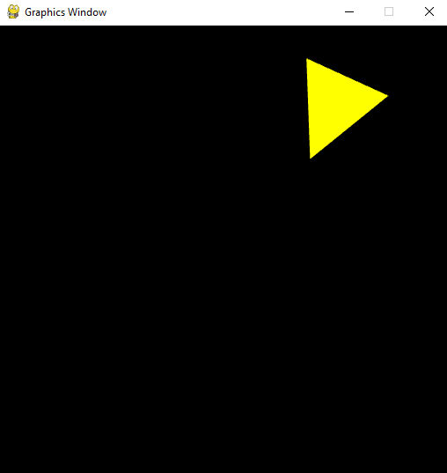
Figure 2.4.1.3. Screenshot of Part D1 – Exercise 1

2.4.2. Two Triangles
2.4.2.1. Solution Code
import math
import OpenGL.GL as GL

from py3d.core.base import Base
from py3d.core.utils import Utils
from py3d.core.attribute import Attribute
from py3d.core.uniform import Uniform

class Example(Base):
"""Two triangles: linear + circular motion"""
def initialize(self):
print("Initializing program...")
vs_code = """
in vec3 position;
uniform vec3 translation;
void main()
{
vec3 pos = position + translation;
gl_Position = vec4(pos, 1.0);
}
"""
fs_code = """
uniform vec3 baseColor;
out vec4 fragColor;
void main()
{
fragColor = vec4(baseColor, 1.0);
}
"""
self.program_ref = Utils.initialize_program(vs_code, fs_code)
GL.glClearColor(0.0, 0.0, 0.0, 1.0)

self.vao1 = GL.glGenVertexArrays(1)
GL.glBindVertexArray(self.vao1)
pos1 = [[ 0.0, 0.1, 0.0],
[ 0.1, -0.1, 0.0],
[-0.1, -0.1, 0.0]]
self.vertex_count = len(pos1)
Attribute('vec3', pos1).associate_variable(self.program_ref, 'position')

self.vao2 = GL.glGenVertexArrays(1)
GL.glBindVertexArray(self.vao2)
pos2 = [[ 0.0, 0.1, 0.0],
[ 0.1, -0.1, 0.0],
[-0.1, -0.1, 0.0]]
Attribute('vec3', pos2).associate_variable(self.program_ref, 'position')

self.translation = Uniform('vec3', [0.0, 0.0, 0.0])
self.translation.locate_variable(self.program_ref, 'translation')
self.base_color = Uniform('vec3', [1.0, 0.0, 0.0])
self.base_color.locate_variable(self.program_ref, 'baseColor')

def update(self):
GL.glClear(GL.GL_COLOR_BUFFER_BIT)
GL.glUseProgram(self.program_ref)

t1_x = -1.2 + (self.time * 0.5) % 2.4
self.translation.data = [t1_x, 0.3, 0.0]
self.base_color.data = [1.0, 0.0, 0.0]
self.translation.upload_data()
self.base_color.upload_data()
GL.glBindVertexArray(self.vao1)
GL.glDrawArrays(GL.GL_TRIANGLES, 0, self.vertex_count)

self.translation.data = [0.5 * math.cos(self.time),
0.5 * math.sin(self.time) - 0.3,
0.0]
self.base_color.data = [0.0, 0.5, 1.0]
self.translation.upload_data()
self.base_color.upload_data()
GL.glBindVertexArray(self.vao2)
GL.glDrawArrays(GL.GL_TRIANGLES, 0, self.vertex_count)

Example().run()

2.4.2.2. Implementation Details and Explanation
a. Two Separate Vertex Array Objects
Each triangle has its own VAO (self.vao1 and self.vao2). While both triangles share the same shader program, they have independent vertex data buffers. This is essential because OpenGL requires binding the correct VAO before each glDrawArrays call to use the right vertex data.

b. Drawing Two Objects with One Shader
The key technique here is re-using the same shader program with different uniform values for each triangle. The draw cycle per frame is:
- Clear the screen
- Set Triangle 1's uniforms → bind VAO 1 → draw
- Set Triangle 2's uniforms → bind VAO 2 → draw
This "set uniforms → draw" pattern is the standard approach for rendering multiple objects with the same shader.

c. Triangle 1 – Linear Motion
t1_x = -1.2 + (self.time * 0.5) % 2.4

- The x-position starts at $-1.2$ (off-screen left) and increases at a speed of $0.5$ units per second.
- The modulo % 2.4 wraps the value back to $0$ after the triangle has traveled $2.4$ units (from $-1.2$ to $+1.2$), creating a seamless loop.
- The y-position is fixed at $0.3$ (upper half of the screen).
- Color: red $\left(1.0 , 0.0 , 0.0\right)$.
The wrapping range of $\left[- , 1.2+1.2\right]$ slightly exceeds the NDC range of $\left[- , 1+1\right]$, so the triangle appears to smoothly enter from the left edge and exit from the right edge before reappearing.

d. Triangle 2 – Circular Motion
self.translation.data = [0.5 * math.cos(self.time),
0.5 * math.sin(self.time) - 0.3,
0.0]

- The triangle follows a circular path with radius $r=0.5$ centered at $\left(0 , -0.3\right)$.
- The $-0.3$ offset in y positions the circular orbit in the lower half of the screen, visually separating it from the linear triangle above.
- Color: blue $\left(0.0 , 0.5 , 1.0\right)$.

e. Vertex Shader – Transation Only
Unlike D1, this shader only applies a translation (no rotation):
vec3 pos = position + translation;
gl_Position = vec4(pos, 1.0);

This is a simple additive translation: $P^{'}=P+T$, which in matrix form is:
$$\left[\begin{matrix}x^{'} \\ y^{'} \\ 1\end{matrix}\right]=\left[\begin{matrix}1 & 0 & t_{x} \\ 0 & 1 & t_{y} \\ 0 & 0 & 1\end{matrix}\right]\left[\begin{matrix}x \\ y \\ 1\end{matrix}\right]$$
2.4.2.4. Screenshot
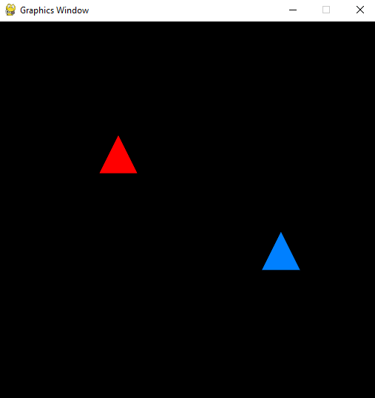
Figure 2.4.2.4. Screenshot of Part D2 – Exercise 1

2.4.3. Linear Motion with Rotation & Circular Motion
2.4.3.1. Solution Code
import math
import OpenGL.GL as GL

from py3d.core.base import Base
from py3d.core.utils import Utils
from py3d.core.attribute import Attribute
from py3d.core.uniform import Uniform

class Example(Base):
"""Triangle A: linear + spin. Triangle B: circular orbit."""
def initialize(self):
print("Initializing program...")
vs_code = """
in vec3 position;
uniform vec3 translation;
uniform float rotation;
void main()
{
float c = cos(rotation);
float s = sin(rotation);
vec3 rotated = vec3(
position.x * c - position.y * s,
position.x * s + position.y * c,
position.z
);
vec3 pos = rotated + translation;
gl_Position = vec4(pos, 1.0);
}
"""
fs_code = """
uniform vec3 baseColor;
out vec4 fragColor;
void main()
{
fragColor = vec4(baseColor, 1.0);
}
"""
self.program_ref = Utils.initialize_program(vs_code, fs_code)
GL.glClearColor(0.0, 0.0, 0.0, 1.0)

self.vao_a = GL.glGenVertexArrays(1)
GL.glBindVertexArray(self.vao_a)
pos = [[0.0, 0.1, 0.0], [0.1, -0.1, 0.0], [-0.1, -0.1, 0.0]]
self.vertex_count = 3
Attribute('vec3', pos).associate_variable(self.program_ref, 'position')

self.vao_b = GL.glGenVertexArrays(1)
GL.glBindVertexArray(self.vao_b)
Attribute('vec3', pos).associate_variable(self.program_ref, 'position')

self.translation = Uniform('vec3', [0.0, 0.0, 0.0])
self.translation.locate_variable(self.program_ref, 'translation')
self.base_color = Uniform('vec3', [1.0, 0.0, 0.0])
self.base_color.locate_variable(self.program_ref, 'baseColor')
self.rotation = Uniform('float', 0.0)
self.rotation.locate_variable(self.program_ref, 'rotation')

def update(self):
GL.glClear(GL.GL_COLOR_BUFFER_BIT)
GL.glUseProgram(self.program_ref)

t_x = -1.2 + (self.time * 0.4) % 2.4
self.translation.data = [t_x, 0.3, 0.0]
self.rotation.data = self.time * 2.0
self.base_color.data = [0.0, 1.0, 0.0]
self.translation.upload_data()
self.rotation.upload_data()
self.base_color.upload_data()
GL.glBindVertexArray(self.vao_a)
GL.glDrawArrays(GL.GL_TRIANGLES, 0, self.vertex_count)

self.translation.data = [0.6 * math.cos(self.time),
0.6 * math.sin(self.time) - 0.3,
0.0]
self.rotation.data = 0.0
self.base_color.data = [0.0, 1.0, 1.0]
self.translation.upload_data()
self.rotation.upload_data()
self.base_color.upload_data()
GL.glBindVertexArray(self.vao_b)
GL.glDrawArrays(GL.GL_TRIANGLES, 0, self.vertex_count)

Example().run()

2.4.3.2. Implementation Details and Explanation
a. Triangle A – Linear Motion & Self-Rotation
Triangle A demonstrates the combined transformation $M=T\left(t_{x} , 0\right)⋅R\left(θ\right)$:
t_x = -1.2 + (self.time * 0.4) % 2.4 # linear motion
self.rotation.data = self.time * 2.0 # self-spin at 2 rad/s

The transformation pipeline in the vertex shader is:
- Rotate the vertex around the local origin: $P_{rotated}=R\left(θ\right)⋅P$
- Translate the rotated vertex to the world position: $P_{final}=P_{rotated}+T$
In matrix notation:
$$P^{'}=T\left(t_{x} , 0.3\right)⋅R\left(2t\right)⋅P=\left[\begin{matrix}cos⁡\left(2t\right) & -sin⁡\left(2t\right) & t_{x} \\ sin⁡\left(2t\right) & cos⁡\left(2t\right) & 0.3 \\ 0 & 0 & 1\end{matrix}\right]\left[\begin{matrix}x \\ y \\ 1\end{matrix}\right]$$
The triangle moves at $0.4$ units/second horizontally (slightly slower than D2's $0.5$) and spins at $2$ radians/second. The green color $\left(0 , 1 , 0\right)$ distinguishes it from the other triangle.

b. Triangle B – Circular Orbit
Triangle B only orbits with no self-rotation:
self.rotation.data = 0.0 # no spin
self.translation.data = [0.6 * math.cos(self.time),
0.6 * math.sin(self.time) - 0.3,
0.0]

Setting rotation = 0.0 causes the rotation matrix to become the identity matrix ($cos⁡\left(0\right)=1$, $sin⁡\left(0\right)=0$), so only the translation is applied. The orbit radius is $r=0.6$, centered at $\left(0 , -0.3\right)$, with a cyan color $\left(0 , 1 , 1\right)$.

c. Key Difference from D1 and D2
This exercise combines elements from both:
- From D1: the rotation uniform and combined rotation + translation in the shader
- From D2: two separate VAOs and the multi-draw technique
The critical insight is that the same vertex shader handles both a rotating triangle (Triangle A, rotation ≠ 0) and a non-rotating triangle (Triangle B, rotation = 0) – demonstrating the flexibility of uniform-driven shaders.

2.4.3.3. Screenshot
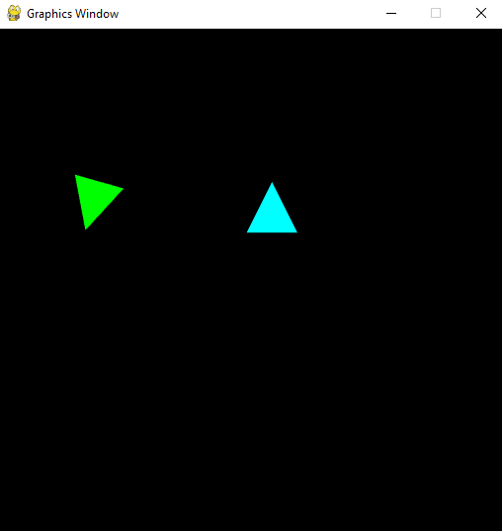
Figure 2.4.3.3. Screenshot of Part D3 – Exercise 1

3. EXERCISE 2 – MATRIX ALGEBRA AND TRANSFORMATIONS
3.1. Solution Code
from math import pi
from py3d.core.base import Base
from py3d.core_ext.camera import Camera
from py3d.core_ext.mesh import Mesh
from py3d.core_ext.renderer import Renderer
from py3d.core_ext.scene import Scene
from py3d.geometry.sphere import SphereGeometry
from py3d.material.material import Material

class Example(Base):
"""Spinning sphere with keyboard controls"""
def initialize(self):
print("Initializing program...")
self.renderer = Renderer()
self.scene = Scene()
self.camera = Camera(aspect_ratio=800/600)
self.camera.set_position([0, 0, 7])
geometry = SphereGeometry(radius=2)
vs_code = """
uniform mat4 modelMatrix;
uniform mat4 viewMatrix;
uniform mat4 projectionMatrix;
in vec3 vertexPosition;
out vec3 position;
void main()
{
vec4 pos = vec4(vertexPosition, 1.0);
gl_Position = projectionMatrix * viewMatrix * modelMatrix * pos;
position = vertexPosition;
}
"""
fs_code = """
in vec3 position;
out vec4 fragColor;
void main()
{
vec3 color = mod(position, 1.0);
fragColor = vec4(color, 1.0);
}
"""
material = Material(vs_code, fs_code)
material.locate_uniforms()
self.mesh = Mesh(geometry, material)
self.scene.add(self.mesh)

self.move_speed = 2.0
self.turn_speed = 90 * (pi / 180)

def update(self):
move_amount = self.move_speed * self.delta_time
turn_amount = self.turn_speed * self.delta_time

if self.input.is_key_pressed('w'):
self.mesh.translate(0, move_amount, 0, local=False)
if self.input.is_key_pressed('s'):
self.mesh.translate(0, -move_amount, 0, local=False)
if self.input.is_key_pressed('a'):
self.mesh.translate(-move_amount, 0, 0, local=False)
if self.input.is_key_pressed('d'):
self.mesh.translate( move_amount, 0, 0, local=False)
if self.input.is_key_pressed('z'):
self.mesh.translate(0, 0, move_amount, local=False)
if self.input.is_key_pressed('x'):
self.mesh.translate(0, 0, -move_amount, local=False)

if self.input.is_key_pressed('q'):
self.mesh.rotate_y( turn_amount, local=False)
if self.input.is_key_pressed('e'):
self.mesh.rotate_y(-turn_amount, local=False)

if self.input.is_key_pressed('i'):
self.mesh.translate(0, move_amount, 0, local=True)
if self.input.is_key_pressed('k'):
self.mesh.translate(0, -move_amount, 0, local=True)
if self.input.is_key_pressed('j'):
self.mesh.translate(-move_amount, 0, 0, local=True)
if self.input.is_key_pressed('l'):
self.mesh.translate( move_amount, 0, 0, local=True)

if self.input.is_key_pressed('u'):
self.mesh.rotate_y( turn_amount, local=True)
if self.input.is_key_pressed('o'):
self.mesh.rotate_y(-turn_amount, local=True)

self.mesh.rotate_y(0.00514)
self.mesh.rotate_x(0.00337)

self.renderer.render(self.scene, self.camera)

Example(screen_size=[800, 600]).run()

3.2. Implementation Details and Explanation
3.2.1. Part A – Global vs Local Translation
Key | Action | Type | Code
W / S | Move up / down | Global | translate(0, ±move, 0, local=False)
A / D | Move left / right | Global | translate(±move, 0, 0, local=False)
Z / X | Move forward / backward | Global | translate(0, 0, ±move, local=False)
I / K | Move up / down | Local | translate(0, ±move, 0, local=True)
J / L | Move left / right | Local | translate(±move, 0, 0, local=True)
Table 3.2.1. Global & Local translation

Why global uses $M=T⋅M$ and local uses $M=M⋅T$:
- Global transformation ($M_{new}=T⋅M_{old}$): The translation matrix $T$ is pre-multiplied (applied to the left). Since matrix multiplication is applied right-to-left, $T$ is applied after all existing transformations. This means the translation happens in the world coordinate system, regardless of the object's current orientation. Pressing W always moves the sphere upward in the world.
- Local transformation ($M_{new}=M_{old}⋅T$): The translation matrix $T$ is post-multiplied (applied to the right). This means $T$ is applied before the existing model transformation, operating in the object's local coordinate system. If the sphere has been rotated, pressing I moves it "forward" relative to its current orientation.

3.2.2. Part B – Interactive Y-axis Rotation
Key | Action | Type
Q | Rotate Y+ (counterclockwise) | Global
E | Rotate Y- (clockwise) | Global
U | Rotate Y+ (counterclockwise) | Local
O | Rotate Y- (clockwise) | Local
Table 3.2.2. Y-axis Rotation

The Y-axis rotation matrix used:
$$R_{y}\left(θ\right)=\left[\begin{matrix}\cos{θ} & 0 & \sin{θ} & 0 \\ 0 & 1 & 0 & 0 \\ -\sin{θ} & 0 & \cos{θ} & 0 \\ 0 & 0 & 0 & 1\end{matrix}\right]$$
Difference between global and local rotation:
- Global rotation rotates the sphere around the world's Y-axis (vertical axis at the world origin). If the sphere has been translated away from the origin, global rotation will cause it to orbit around the world Y-axis.
- Local rotation rotates the sphere around its own Y-axis. The sphere spins in place, regardless of its position in the world. This is equivalent to the object spinning on its own axis.

3.2.3. Part C – Auto-Spin Combined with Controls
The auto-spin is applied every frame regardless of user input:
self.mesh.rotate_y(0.00514)
self.mesh.rotate_x(0.00337)

These small per-frame rotations accumulate, making the sphere spin continuously around both the X and Y axes. The irrational-looking values ($0.00514$ and $0.00337$) ensure the spin pattern doesn't repeat exactly, creating a visually interesting tumbling effect.

3.2.4. Full Transformation Pipeline
The complete pipeline for transforming a vertex from object space to clip space is:
$$gl_Position=P_{projection}×V_{view}×M_{model}×P_{vertex}$$
Where:
- $P_{vertex}$: the original vertex position in object space
- $M_{model}$: the model matrix (combines all translations, rotations, and scales applied to the mesh)
- $V_{view}$: the view matrix (derived from the camera position and orientation)
- $P_{projection}$: the projection matrix (perspective projection with the camera's aspect ratio)

3.2.5. Frame-Rate Independent Movement
move_amount = self.move_speed * self.delta_time
turn_amount = self.turn_speed * self.delta_time

By multiplying by delta_time (time elapsed since the last frame), the movement speed is consistent regardless of frame rate. At 60 FPS, delta_time ≈ 0.0167s, giving move_amount ≈ 0.033 units per frame. At 30 FPS, delta_time ≈ 0.033s, giving move_amount ≈ 0.067 — twice as much per frame, but at half the frame rate, yielding the same perceived speed.

3.2.6. Screenshot
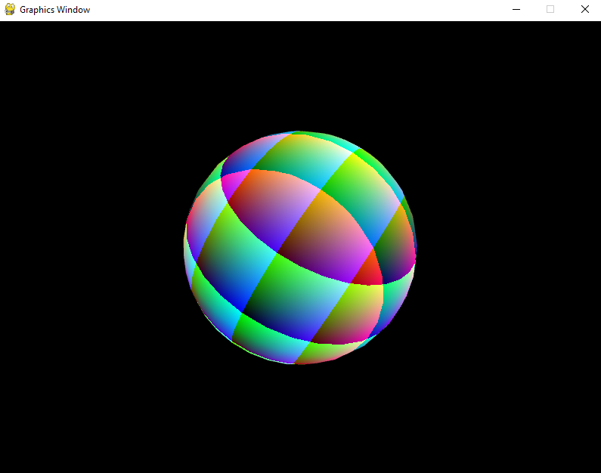
Figure 3.2.6. Screenshot of Exercise 2

4. HOMEWORK
4.1. Question 1 – Spinning Sun
4.1.1. Solution Code
from py3d.core.base import Base
from py3d.core_ext.camera import Camera
from py3d.core_ext.mesh import Mesh
from py3d.core_ext.renderer import Renderer
from py3d.core_ext.scene import Scene
from py3d.geometry.sphere import SphereGeometry
from py3d.material.material import Material

class Example(Base):
"""Solar System"""
def initialize(self):
print("Initializing program...")
self.renderer = Renderer()
self.scene = Scene()
self.camera = Camera(aspect_ratio=800/600)
self.camera.set_position([0, 0, 12])

vs_code = """
uniform mat4 modelMatrix;
uniform mat4 viewMatrix;
uniform mat4 projectionMatrix;
in vec3 vertexPosition;
out vec3 position;
void main()
{
vec4 pos = vec4(vertexPosition, 1.0);
gl_Position = projectionMatrix * viewMatrix * modelMatrix * pos;
position = vertexPosition;
}
"""
fs_code = """
in vec3 position;
out vec4 fragColor;
void main()
{
vec3 color = mod(position, 1.0);
fragColor = vec4(color, 1.0);
}
"""
material = Material(vs_code, fs_code)
material.locate_uniforms()

sun_geometry = SphereGeometry(radius=1.0)
self.sun = Mesh(sun_geometry, material)
self.scene.add(self.sun)

def update(self):
self.sun.rotate_y(0.01)

self.renderer.render(self.scene, self.camera)

Example(screen_size=[800, 600]).run()

4.1.2. Implementation Details and Explanation
4.1.2.1. Sun Creation
sun_geometry = SphereGeometry(radius=1.0)
self.sun = Mesh(sun_geometry, material)
self.scene.add(self.sun)

A sphere mesh with radius $1.0$ is created using SphereGeometry, which generates a UV-sphere with vertices arranged along latitude/longitude lines. The mesh is added to the scene graph.

4.1.2.2. Continuous Y-axis Rotation
def update(self):
self.sun.rotate_y(0.01)

Each frame, the Sun is rotated by $0.01$ radians ($≈0.573°$) around its Y-axis. This is a local rotation — the Sun spins in place. At 60 FPS, the Sun completes one full rotation ($2π$ radians) in approximately $\frac{2π}{0.01×60}≈10.5$ seconds.

4.1.2.3. Gradient Shader for Visible Rotation
The fragment shader vec3 color = mod(position, 1.0) maps vertex positions to colors using modular arithmetic. Since the vertex positions are in object space (passed through the position varying), the colors are fixed relative to the sphere's surface. As the sphere rotates, the color bands move with it, making the rotation clearly visible. Without this gradient, the sphere would appear stationary since it's a uniform color.

4.1.2.4. Camera Setup
self.camera.set_position([0, 0, 12])

The camera is positioned at $z=12$, looking toward the origin. This provides enough distance to view the entire solar system in later questions.

4.1.3. Screenshot
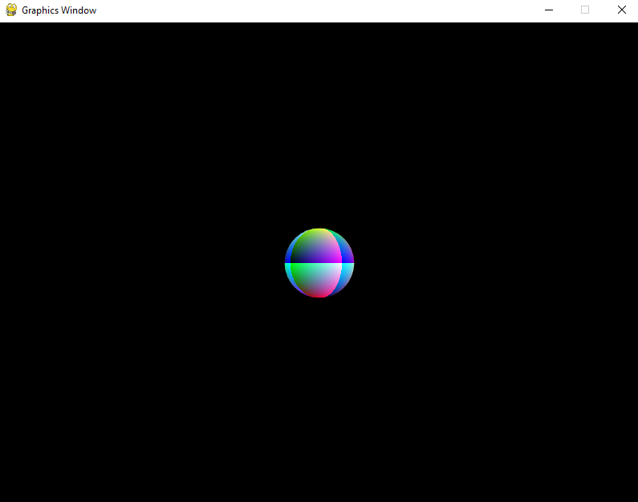
Figure 4.1.3. Screenshot of Question 1 – Homework

4.2. Question 2 – Adding the Earth
4.2.1. Solution Code
from py3d.core.base import Base
from py3d.core_ext.camera import Camera
from py3d.core_ext.mesh import Mesh
from py3d.core_ext.renderer import Renderer
from py3d.core_ext.scene import Scene
from py3d.geometry.sphere import SphereGeometry
from py3d.material.material import Material

class Example(Base):
"""Solar System"""
def initialize(self):
print("Initializing program...")
self.renderer = Renderer()
self.scene = Scene()
self.camera = Camera(aspect_ratio=800/600)
self.camera.set_position([0, 0, 12])

vs_code = """
uniform mat4 modelMatrix;
uniform mat4 viewMatrix;
uniform mat4 projectionMatrix;
in vec3 vertexPosition;
out vec3 position;
void main()
{
vec4 pos = vec4(vertexPosition, 1.0);
gl_Position = projectionMatrix * viewMatrix * modelMatrix * pos;
position = vertexPosition;
}
"""
fs_code = """
in vec3 position;
out vec4 fragColor;
void main()
{
vec3 color = mod(position, 1.0);
fragColor = vec4(color, 1.0);
}
"""
material = Material(vs_code, fs_code)
material.locate_uniforms()

sun_geometry = SphereGeometry(radius=1.0)
self.sun = Mesh(sun_geometry, material)
self.scene.add(self.sun)

earth_geometry = SphereGeometry(radius=0.5)
earth_material = Material(vs_code, fs_code)
earth_material.locate_uniforms()
self.earth = Mesh(earth_geometry, earth_material)
self.scene.add(self.earth)

self.earth_orbit_radius = 3.0
self.earth_orbit_speed = 1.0

def update(self):
self.sun.rotate_y(0.01)

self.renderer.render(self.scene, self.camera)

import math
earth_angle = self.time * self.earth_orbit_speed
earth_x = self.earth_orbit_radius * math.cos(earth_angle)
earth_z = self.earth_orbit_radius * math.sin(earth_angle)
self.earth.set_position([earth_x, 0, earth_z])

Example(screen_size=[800, 600]).run()

4.2.2. Implementation Details and Explanation
4.2.2.1. Earth Sphere Creation
earth_geometry = SphereGeometry(radius=0.5)
earth_material = Material(vs_code, fs_code)
earth_material.locate_uniforms()
self.earth = Mesh(earth_geometry, earth_material)
self.scene.add(self.earth)

The Earth is a separate sphere with radius $0.5$ (half the Sun's size). It requires its own Material instance because each mesh needs independent uniform locations. Sharing the same Material object would cause uniform conflicts between meshes.

4.2.2.2. Circular Orbit Computation
earth_angle = self.time * self.earth_orbit_speed # θ = t × 1.0
earth_x = self.earth_orbit_radius * math.cos(earth_angle) # x = 3.0 × cos(θ)
earth_z = self.earth_orbit_radius * math.sin(earth_angle) # z = 3.0 × sin(θ)
self.earth.set_position([earth_x, 0, earth_z])

The Earth's position is computed using the parametric circle equations:
$$x_{earth}=R⋅cos⁡\left(θ\right), z_{earth}=R⋅sin⁡\left(θ\right)$$
where $R=3.0$ and $θ=t×ω_{orbit}$ with $ω_{orbit}=1.0$ rad/s.
Note that the orbit is in the XZ-plane (horizontal plane), not the XY-plane. This is because in 3D space with the camera looking down the Z-axis, the XZ-plane appears as a horizontal circle when viewed from above or at an angle — matching how planetary orbits appear.

4.2.2.3. set_position vs translate
The code uses set_position instead of translate. This is critical:
- set_position sets an absolute position each frame, directly updating the translation component of the model matrix.
- translate would accumulate translations frame-over-frame, causing the Earth to spiral outward.
Since we recompute the exact position from the parametric equation each frame, set_position is the correct choice.

4.2.3. Screenshot
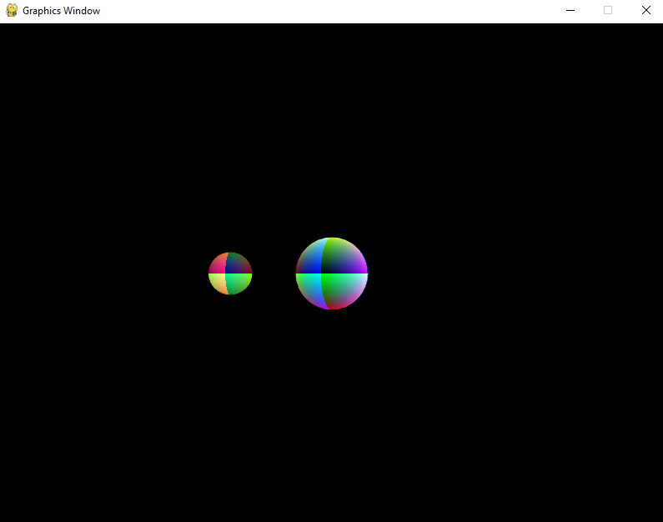
Figure 4.2.3. Screenshot of Question 2 – Homework

4.3. Question 3 – Earth's Self-Spin
4.3.1. Solution Code
import numpy as np
import math
from py3d.core.base import Base
from py3d.core_ext.camera import Camera
from py3d.core_ext.mesh import Mesh
from py3d.core_ext.renderer import Renderer
from py3d.core_ext.scene import Scene
from py3d.geometry.sphere import SphereGeometry
from py3d.material.material import Material
from py3d.core.matrix import Matrix

class Example(Base):
"""Solar System"""
def initialize(self):
print("Initializing program...")
self.renderer = Renderer()
self.scene = Scene()
self.camera = Camera(aspect_ratio=800/600)
self.camera.set_position([0, 0, 12])

vs_code = """
uniform mat4 modelMatrix;
uniform mat4 viewMatrix;
uniform mat4 projectionMatrix;
in vec3 vertexPosition;
out vec3 position;
void main()
{
vec4 pos = vec4(vertexPosition, 1.0);
gl_Position = projectionMatrix * viewMatrix * modelMatrix * pos;
position = vertexPosition;
}
"""
fs_code = """
in vec3 position;
out vec4 fragColor;
void main()
{
vec3 color = mod(position, 1.0);
fragColor = vec4(color, 1.0);
}
"""
material = Material(vs_code, fs_code)
material.locate_uniforms()

sun_geometry = SphereGeometry(radius=1.0)
self.sun = Mesh(sun_geometry, material)
self.scene.add(self.sun)

earth_geometry = SphereGeometry(radius=0.5)
earth_material = Material(vs_code, fs_code)
earth_material.locate_uniforms()
self.earth = Mesh(earth_geometry, earth_material)
self.scene.add(self.earth)

self.earth_orbit_radius = 3.0
self.earth_orbit_speed = 1.0

def update(self):
self.sun.rotate_y(0.01)

self.renderer.render(self.scene, self.camera)

earth_angle = self.time * self.earth_orbit_speed
earth_x = self.earth_orbit_radius * math.cos(earth_angle)
earth_z = self.earth_orbit_radius * math.sin(earth_angle)

earth_spin_angle = self.time * 3.0
T = Matrix.make_translation(earth_x, 0, earth_z)
R = Matrix.make_rotation_y(earth_spin_angle)
self.earth.local_matrix = T @ R

Example(screen_size=[800, 600]).run()

4.3.2. Implementation Details and Explanation
4.3.2.1. Combined Transformation – Translation × Rotation
The key change from Q2 is replacing set_position with a manually composed model matrix:
earth_spin_angle = self.time * 3.0
T = Matrix.make_translation(earth_x, 0, earth_z)
R = Matrix.make_rotation_y(earth_spin_angle)
self.earth.local_matrix = T @ R

The Earth's model matrix is computed as:
$$M_{earth}=T\left(x_{earth} , 0 , z_{earth}\right)⋅R_{y}\left(θ_{spin}\right)$$
Where:
- $T$ = translation matrix that moves the Earth to its orbital position
- $R_{y}$ = rotation matrix that spins the Earth around its Y-axis

4.3.2.2. Transformation Order (T × R)
The order $T⋅R$ is critical. Since matrix transformations are applied right-to-left:
- First, $R$ is applied: The Earth's vertices are rotated around the local Y-axis (the Earth spins around its own center).
- Then, $T$ is applied: The rotated Earth is translated to its position on the orbital circle.
If the order were reversed ($R⋅T$), the Earth would first be translated to its orbital position, then rotated around the world Y-axis — this would cause the Earth to orbit around the Sun's Y-axis rather than spinning in place.

4.3.2.3. Earth's Spin Speed
earth_spin_angle = self.time * 3.0

The spin speed is $3.0$ rad/s, which is $3×$ faster than the orbital speed ($1.0$ rad/s). This means the Earth completes 3 full rotations for every one orbit, making the self-spin clearly visible.

4.3.2.4. Using local_matrix Directly
Instead of calling translate() and rotate_y() (which accumulate transformations), we directly set self.earth.local_matrix = T @ R. This is a fresh computation each frame, avoiding floating-point drift from accumulated matrix multiplications. The @ operator performs matrix multiplication (Python's __matmul__).

4.3.2.5. Why Both Transformations Are Needed
In reality, the Earth simultaneously:
- Orbits the Sun (revolution) — modeled by the translation $T$
- Spins on its axis (rotation) — modeled by the rotation $R_{y}$
Without the orbit (no $T$), the Earth would spin in place at the origin, coinciding with the Sun. Without the spin (no $R_{y}$), the Earth would orbit but always show the same face — like Q2, where the gradient pattern doesn't change. The combination of both creates a realistic simulation where the Earth orbits the Sun while also spinning on its own axis.

4.3.3. Screenshot
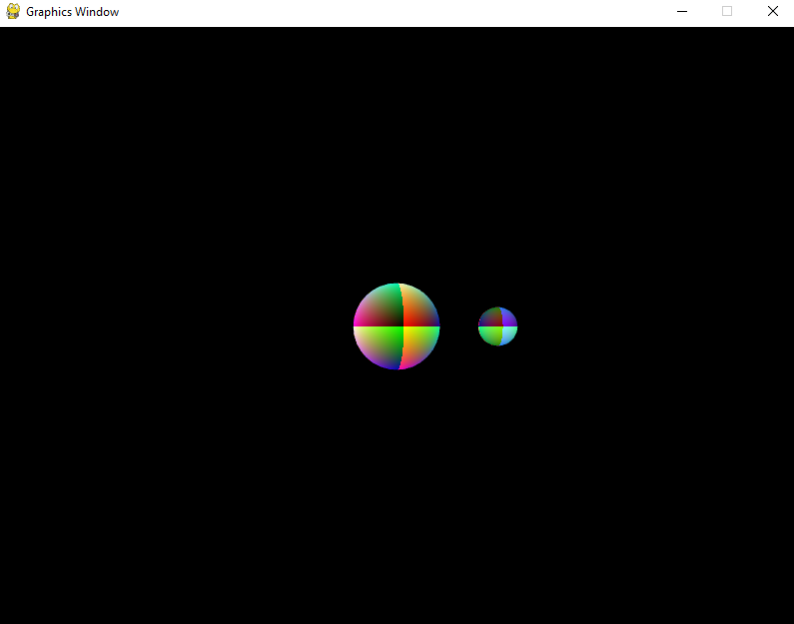
Figure 4.3.3. Screenshot of Question 3 – Homework

4.4. Question 4 – Adding the Moon
4.4.1. Solution Code
import numpy as np
import math
from py3d.core.base import Base
from py3d.core_ext.camera import Camera
from py3d.core_ext.mesh import Mesh
from py3d.core_ext.renderer import Renderer
from py3d.core_ext.scene import Scene
from py3d.geometry.sphere import SphereGeometry
from py3d.material.material import Material
from py3d.core.matrix import Matrix

class Example(Base):
"""Solar System"""
def initialize(self):
print("Initializing program...")
self.renderer = Renderer()
self.scene = Scene()
self.camera = Camera(aspect_ratio=800/600)
self.camera.set_position([0, 0, 12])

vs_code = """
uniform mat4 modelMatrix;
uniform mat4 viewMatrix;
uniform mat4 projectionMatrix;
in vec3 vertexPosition;
out vec3 position;
void main()
{
vec4 pos = vec4(vertexPosition, 1.0);
gl_Position = projectionMatrix * viewMatrix * modelMatrix * pos;
position = vertexPosition;
}
"""
fs_code = """
in vec3 position;
out vec4 fragColor;
void main()
{
vec3 color = mod(position, 1.0);
fragColor = vec4(color, 1.0);
}
"""
material = Material(vs_code, fs_code)
material.locate_uniforms()

sun_geometry = SphereGeometry(radius=1.0)
self.sun = Mesh(sun_geometry, material)
self.scene.add(self.sun)

earth_geometry = SphereGeometry(radius=0.5)
earth_material = Material(vs_code, fs_code)
earth_material.locate_uniforms()
self.earth = Mesh(earth_geometry, earth_material)
self.scene.add(self.earth)

self.earth_orbit_radius = 3.0
self.earth_orbit_speed = 1.0

moon_geometry = SphereGeometry(radius=0.2)
moon_material = Material(vs_code, fs_code)
moon_material.locate_uniforms()
self.moon = Mesh(moon_geometry, moon_material)
self.scene.add(self.moon)

self.moon_orbit_radius = 1.0
self.moon_orbit_speed = 3.0

def update(self):
self.sun.rotate_y(0.01)

self.renderer.render(self.scene, self.camera)

earth_angle = self.time * self.earth_orbit_speed
earth_x = self.earth_orbit_radius * math.cos(earth_angle)
earth_z = self.earth_orbit_radius * math.sin(earth_angle)

earth_spin_angle = self.time * 3.0
T = Matrix.make_translation(earth_x, 0, earth_z)
R = Matrix.make_rotation_y(earth_spin_angle)
self.earth.local_matrix = T @ R

moon_angle = self.time * self.moon_orbit_speed
moon_x = earth_x + self.moon_orbit_radius * math.cos(moon_angle)
moon_z = earth_z + self.moon_orbit_radius * math.sin(moon_angle)

moon_spin_angle = self.time * 5.0
T_moon = Matrix.make_translation(moon_x, 0, moon_z)
R_moon = Matrix.make_rotation_y(moon_spin_angle)
self.moon.local_matrix = T_moon @ R_moon

Example(screen_size=[800, 600]).run()

4.4.2. Implementation Details and Explanation
4.4.2.1. Moon Creation
moon_geometry = SphereGeometry(radius=0.2)
moon_material = Material(vs_code, fs_code)
moon_material.locate_uniforms()
self.moon = Mesh(moon_geometry, moon_material)
self.scene.add(self.moon)

self.moon_orbit_radius = 1.0
self.moon_orbit_speed = 3.0

The Moon is the smallest sphere ($r=0.2$), orbiting at radius $1.0$ around the Earth with a speed of $3.0$ rad/s — 3× faster than Earth's orbital speed, creating a visually interesting nested orbit effect.

4.4.2.2. Moon's Orbit – Relative to Earth
moon_angle = self.time * self.moon_orbit_speed
moon_x = earth_x + self.moon_orbit_radius * math.cos(moon_angle)
moon_z = earth_z + self.moon_orbit_radius * math.sin(moon_angle)

The Moon's position is computed relative to the Earth's current position:
$$x_{moon}=x_{earth}+r_{moon}⋅cos⁡\left(ϕ\right)$$
$$z_{moon}=z_{earth}+r_{moon}⋅sin⁡\left(ϕ\right)$$
Where:
- $\left(x_{earth} , z_{earth}\right)$: Earth's position from the orbit computation in Q3
- $r_{moon}=1.0$: Moon's orbit radius around Earth
- $ϕ=t×ω_{moon}$ with $ω_{moon}=3.0$ rad/s
This creates a compound circular motion — the Moon traces an epicycloid path in world space (a circle around a moving circle).

4.4.2.3. Moon's Combined Transformation
moon_spin_angle = self.time * 5.0
T_moon = Matrix.make_translation(moon_x, 0, moon_z)
R_moon = Matrix.make_rotation_y(moon_spin_angle)
self.moon.local_matrix = T_moon @ R_moon

The Moon's model matrix follows the same $T⋅R$ pattern as the Earth:
$$M_{moon}=T\left(x_{moon} , 0 , z_{moon}\right)⋅R_{y}\left(θ_{moon_spin}\right)$$
The Moon's self-spin speed is $5.0$ rad/s — the fastest in the system — making its gradient pattern change rapidly.

4.4.2.4. Complete Solar System Hierarchy
The final simulation contains three celestial bodies with these parameters:
Body | Radius | Orbit Radius | Orbit Speed | Spin Speed | Orbits Around
Sun | 1.0 | — | — | 0.01 rad/frame | — (center)
Earth | 0.5 | 3.0 | 1.0 rad/s | 3.0 rad/s | Sun
Moon | 0.2 | 1.0 | 3.0 rad/s | 5.0 rad/s | Earth
Table 4.4.2.4. Solar System Hierarchy

4.4.2.5. Transformation Hierarchy
The full transformation pipeline for each body's vertex:
$$gl_Position=P_{proj}×V_{view}×M_{model}×P_{vertex}$$
Where $M_{model}$ for each body is:
- Sun: $M_{sun}$ = accumulated rotations from rotate_y(0.01) each frame
- Earth: $M_{earth}=T\left(x_{e} , 0 , z_{e}\right)⋅R_{y}\left(3t\right)$
- Moon: $M_{moon}=T\left(x_{m} , 0 , z_{m}\right)⋅R_{y}\left(5t\right)$
The Moon's world position depends on Earth's position, creating a hierarchical transformation chain typical of scene graphs in computer graphics.

4.4.3. Screenshot
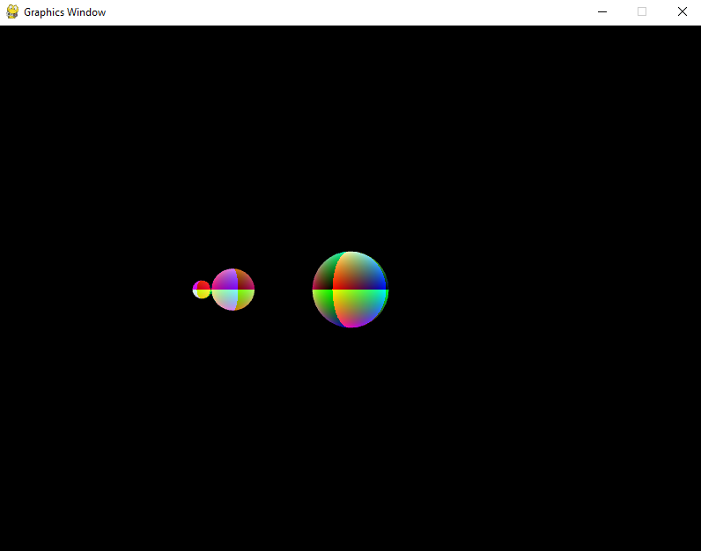
Figure 4.4.3. Screenshot of Question 4 – Homework

